Comp 3716
Assignment #1
Group #12
Kyle Nickerson,
Catherine Rendell &
Ben Morrison.

Set of use cases

1. Principal creates schedule.
2. Applicant requests room.
3. Principal approves a request.
4. Principal rejects a request.
5. Principal blacks out time period for special event.
6. Principal edits available use spaces (Adds/deletes spaces).
7. User (principal or applicant) views the allocation schedule.
8. Applicant rescinds booking request.
9. Applicant cancels confirmed booking request
10. Principal cancels existing booking.
11. Principal changes max request time of an applicant.

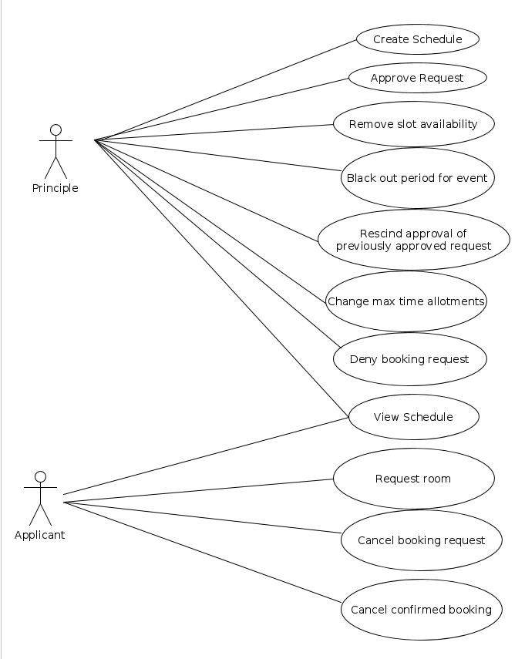

UC: Principal approves request

1. The principal starts the program and indicates that he/she is the principal
2. The system displays the list of possible actions the principal can take
3. The principal chooses to approve request
4. There are or are not available requests
4a. The system displays a list of pending requests
4b. The system informs the principal there are no pending requests
1. Repeat steps 2-10 as needed
5. The principal selects one of the pending requests
6. The system displays the specifics of the request (time slot, group name, etc.)
7. The system prompts the principal to approve or decline the request
8. The principal approves or declines the request
8a. The principal approves the request
1. There is no scheduling conflict
1.1 The system stores the approved request in the schedule
2. There is a scheduling conflict
2.1 The system warns the principal there is a scheduling conflict
2.2 The principal is prompted to decline one of the requests
2.3 The principal chooses a request to decline
2.4 The system updates the schedule
8b. The principal declines the request
9. The system prompts the principal to keep approving requests
10. The principal decides whether to continue reviewing requests
10a. The principal declines to keep reviewing requests
10b. The principal continues reviewing requests
1. Repeat steps 4-10 as needed
11. The system displays the updated schedule

UC: Applicant requests a room

1. User identifies self as Applicant
2. Applicant determines which space they would like too book.
3. Applicant determines when they would like to book the space for.
4. Applicant checks allocation schedule, too ensure this booking is available.
Repeat steps 2-4 until an available space and time are chosen.
5. Applicant submits booking request.
5a. Applicant rescinds booking request.
1. Applicant issues requests to cancel their booking request.
2. Applicant receives confirmation of cancellation of their request.
6. Applicant is notified their booking request was confirmed or denied.
Repeat steps 2-6 until request is confirmed

UC: Principal creates schedule

1. Principal starts system
2. System displays list of possible actions
3. Principal selects option to create schedule
4. System prompts principal to enter room names
5. Principal enters room names
6. System prompts principal for each rooms availability
7. Principal enters each rooms availability
8. The system displays blank schedule for confirmation
8a. Principal confirms schedule is correct
8b. Principal rejects schedule
1. Repeat steps 4-8 as needed
9. System stores the empty schedule

